

A Project Report

On

**“ A ONE STOP SOLUTION FOCUSING ON TOURISM ”**

Batch Details

|  |  |  |
| --- | --- | --- |
| Sl. No. | Roll Number | Student Name |
| 1 | 20211CSE0670 | L S GAGAN |
| 2 | 20211CSE0637 | ANJAN G |
| 3 | 20211CSE0608 | SANJANA S |
| 4 | 20211CSE0678 | SOUNDARYA SARASHETTI |
| 5 | 20211CSE0662 | APEKSHA CHANGOLI |

**School of Computer Science,**

**Presidency University, Bengaluru.**

Under the guidance of,

**Mr.Syed Mohsin Abbasi**

School of Computer Science,

Presidency University, Bengaluru

**CONTENTS**

1. Introduction about Project
2. Literature Review
3. Objectives

## Methodology

1. Timeline for Execution of Project
2. Expected Outcomes
3. Conclusion
4. References

**1.INTRODUCTION**

In the modern era of globalization, travel has become more accessible than ever before. Whether for leisure, business, or exploration, people are constantly on the move, venturing into new cities and countries. However, traveling to unfamiliar places often comes with challenges, especially when it comes to organizing logistics such as accommodation, transportation, and local activities. Tourists and travelers face difficulties in finding reliable services, navigating local events, and making reservations, all while ensuring that they don’t waste precious time.

While there are many apps and websites available today that offer solutions for specific travel needs—like booking hotels, hiring cabs, or purchasing tickets for local events—there is a significant gap in providing a unified, all-in-one platform that can handle all these needs seamlessly. Currently, travelers must toggle between different apps: one for booking hotels, another for cab services, yet another for show or event tickets. This fragmentation of services adds unnecessary complexity and consumes valuable time, making the travel experience more stressful than it needs to be.

This project aims to address these challenges by developing a comprehensive tourism app that will serve as a one-stop solution for all travel-related needs. The app will integrate multiple services, such as hotel bookings, cab reservations, local events, shows, and activities, into one convenient platform. By doing so, it will eliminate the need for users to switch between various applications, offering a cohesive and efficient experience.

The goal of the project is to create an intuitive, user-friendly interface that provides travelers with easy access to a wide range of services from the moment they start planning their trip to the time they return home. Whether they need to book a hotel room, arrange transportation, or find local entertainment, users will be able to do it all within a single app. By offering a streamlined, time-saving experience, this app will improve user satisfaction and significantly enhance the overall travel experience.

In today's fast-paced world, travel has become an integral part of people's lives, whether for leisure, business, or exploration. However, navigating through an unfamiliar city or country can often be overwhelming, especially when travelers have to juggle multiple apps and websites to book accommodations, transportation, local events, and activities. While there are several platforms offering individual services such as hotel bookings, cab reservations, and event ticketing, users are left dealing with fragmented solutions, consuming both time and effort.

The primary aim of this project is to address this problem by creating a one-stop solution in the form of a tourism app. This app will integrate a variety of travel-related services—hotels, cabs, local shows, events, and activities—into a single platform, providing users with a streamlined, efficient, and user-friendly experience. The project seeks to combine the functionality of several standalone apps into one cohesive system, offering a comprehensive solution for modern-day travelers. The result will be a simplified travel experience, saving time and improving user satisfaction.

**2.LITERATURE REVIEW**

Technology has affected almost all aspects of human life, and the travel industry is no omission. The demand for innovative solutions that help in an efficient trip planning is growing day by day with increasing number of travelers. Our comprehensive travel planning system is an approach to cater to such requirements of the present-day travelers and assist them by streamlining the trip planning procedure. The traditional approach to travel planning often involves extensive research, which can be time-consuming and it becomes a challenging task for the travelers to choose from so many overwhelming options and make well informed decisions [1]

For example, a Travel Recommendation System should help the user in answering most of the questions related to tours, such as the best place to visit in the summer, the best time of the year for trekking, and the best way to do it. [2]

These systems have evolved a lot from initially giving only some rudimentary solutions to sophisticated platforms capable of producing good quality suggestions which are both real-time as well as context-aware. In the earlier versions, it has been observed that the recommendation systems used to struggle in providing quality insights because they had a limited access to data and unavailability of complex algorithms. However, with developments in technology and the proliferation of data sources over the years, the present-day recommendation systems are very capable of not only analyzing vast datasets but also giving actionable insights with unprecedented accuracy and efficiency. With the help of these, the people can now easily navigate the complexities of travel planning confidently [3].

In recent years, travel route planning has attracted a great deal of research attention from such fields as operations research, computer science and applications, graph theory, and mathematics [4]

The results of investigation and analysis are combined to determine the main influencing factors of establishes a relatively complete optimal route-planning model based on tourists’ expectations. The grey entropy evaluation method is introduced into the model. The influencing factors are regarded as multiple attributes of uncertain decision-making and the evaluation indexes of scenic spots are analyzed in the work. Also, Dijkstra rithm is applied to obtain optimal tourist route in [5].

The division of work on travel planning itinerary is into two categories: Data Analysis and Synthesis for tourism. In terms of the former, several research is conducted on assessing the exciting point of patterns based on geospatial and the material evidence left by the passengers. These works primarily focus on analysis rather than synthesis of the exciting point of a user. There also exists a variety of works that have been developed for touristic information synthesis that is related to tourism [6].

The MOEA/D method has achieved some research and application results in solving multi-objective problems [7] [8]. Jiang et al. [9]proposed an improved decomposition based modified multi-objective evolutionary algorithm to study the efficient distributed job shop scheduling problem based on minimum completion time and energy consumption [10]

**3.OBJECTIVES**

1. Integrate Multiple Travel Services:
   * Develop a single platform that combines hotel bookings, transportation (cabs, rentals), event ticketing, and local activity reservations, providing a unified solution for all traveler needs
2. Enhance User Experience:
   * Create a user-friendly and intuitive interface that simplifies travel planning, ensuring even non-tech-savvy users can navigate the app easily and efficiently.
3. Save Time and Effort for Users:
   * Eliminate the need for travelers to switch between multiple apps, streamlining the booking process and reducing the time spent on organizing trips.
4. Provide Personalized Recommendations:
   * Incorporate machine learning or AI-based algorithms to offer personalized suggestions based on user preferences, travel history, and location, improving the overall experience.
5. Ensure Seamless Integration:
   * Collaborate with third-party service providers for real-time bookings, ensuring smooth integration across hotel reservations, cab services, and event ticketing systems.
6. Offer Comprehensive Coverage:
   * Expand the platform to include services for various cities and countries, ensuring that users can rely on the app whether traveling domestically or internationally.
7. Ensure Competitive Pricing and Deals:
   * Partner with travel service providers to offer competitive prices, discounts, and bundled deals, making the app a cost-effective solution for travelers.
8. Facilitate Real-Time Updates and Notifications:
   * Implement real-time alerts for bookings, changes, cancellations, or any other travel-related updates to keep users informed and prepared during their journey.
9. Build a Scalable Platform:
   * Develop the app in a way that allows for future expansion, including the potential integration of additional services such as flight bookings, travel insurance, and restaurant reservations.

**4.EXPERIMENTAL DETAILS**

**Software’s used**:

* Frontend: HTML/CSS, JavaScript, React/Angular for a responsive interface.
* Backend: Node.js
* Database: MySQL for data storage.
* APIs: Integrate external APIs for hotels, flights, weather, maps, and payment gateways.
* AI/ML: Implement recommendation systems and chatbots for personalized user experiences.

**5.METHODOLOGY**

**I**. **Requirement Gathering and Analysis:**

This phase is the foundation of the project, where the core needs of the users and stakeholders are identified.

A thorough analysis helps to align the app's features with the project's goals.

* Stakeholder Identification:Identify key stakeholders, including end-users (travelers), service providers (hotels, transportation companies, event organizers), and app administrators.
* User Needs and Expectations:Conduct surveys, interviews, and focus groups with potential users to understand their travel-related pain points, current app usage behavior, and expectations from an all-in-one solution.Collect feedback from service providers (e.g., hotel managers, event organizers) to integrate their services smoothly.
* Functional and Non-Functional Requirements:Define the core features, including hotel booking, cab reservation, event ticketing, personalized recommendations, user account management, payment gateway integration, and push notifications. Determine performance requirements such as app responsiveness, scalability, data security, ease of use, and cross-platform compatibility (Android, iOS, web).
* Competitive Analysis:Study existing apps like Booking.com, Airbnb, Uber, and others to identify their strengths and weaknesses. Analyze user reviews and ratings to understand common issues and limitations.
* Requirement Specification Document:Compile all the gathered data into a requirement specification document, which will serve as the blueprint for the app development. This document will include detailed descriptions of the app’s functionality, user flows, and technical specifications.

**II. System Architecture Design:**

The system architecture design involves creating a blueprint for how the app’s components will interact with each

This phase focuses on the backend infrastructure, frontend interface, and data flow across the system.

* System Components:
  + Frontend: The user interface (UI) for mobile apps (Android and iOS) and the web app. Ensure a consistent user experience across platforms.
  + Backend: The server-side logic that processes user requests, handles bookings, stores data, and manages integrations with external services (hotels, cabs, events).
  + Database: A relational or NoSQL database to store user data, booking history, service details, payment transactions, etc.
* Data Flow Design:Design how data will flow between the user interface and the backend system, focusing on optimizing performance and ensuring data security (e.g., SSL encryption for transactions).Define APIs for communication between the app and third-party service providers (e.g., APIs for hotel booking, cab services, and event management systems).
* Microservices Architecture:Consider using a microservices architecture to modularize the different components of the app (e.g., hotel booking service, payment service, event booking service). This allows independent updates and scalability.
* Cloud Integration:Plan for cloud storage and hosting services (e.g., AWS, Google Cloud) to handle user data, media files, and the app's scalability needs.Integrate third-party services like Google Maps for location-based services and Stripe or PayPal for payments.
* System Security and Data Privacy:Ensure compliance with data privacy regulations (e.g., GDPR) by implementing secure authentication mechanisms, data encryption, and user consent management for data usage.
* Scalability and Load Balancing:Design the system with scalability in mind to handle high traffic during peak travel seasons, incorporating load balancing and server auto-scaling features

**III. Development of Key Features**

Once the requirements and architecture are established, the development process focuses on building the key features

of the app in a systematic and iterative way, ensuring functionality, user experience, and performance.

1. User Interface (UI) Development:
   * Design: Begin by creating wireframes and UI mockups for mobile and web interfaces. Prioritize a clean, intuitive design that focuses on simplicity and ease of use.
   * Implementation: Develop the frontend using technologies such as React Native (for mobile) or Flutter to ensure cross-platform compatibility. Ensure smooth navigation, responsiveness, and visual consistency.
2. Backend Development:
   * API Integration: Develop the backend logic for managing bookings, user accounts, and payments. Integrate third-party APIs for hotel reservations, cab services, and event ticketing.
   * Booking System: Build the core booking functionality, including real-time availability checks, reservation confirmation, and booking history management for users.
   * Database Implementation: Set up a secure database (e.g., MySQL, MongoDB) for storing user data, booking records, payment transactions, and service details.
3. Personalization Engine:
   * Develop machine learning algorithms to analyze user preferences and behavior, offering personalized recommendations for hotels, transportation, and local events.
   * Implement recommendation logic to offer real-time suggestions based on location, user profile, and previous interactions.
4. Payment Gateway Integration:
   * Integrate secure payment gateways (e.g., Stripe, PayPal) to allow users to complete transactions directly within the app.
   * Include multiple payment options (credit/debit cards, digital wallets) for user convenience.
5. Notifications and Alerts:
   * Implement a notification system to send real-time alerts to users for booking confirmations, reminders, cancellations, and updates on upcoming events or reservations.
   * Ensure push notifications work seamlessly across Android, iOS, and web platforms.
6. Testing and Quality Assurance:
   * Conduct rigorous testing, including unit testing, integration testing, and user acceptance testing (UAT), to ensure that all features work as expected and meet performance standards.
   * Focus on cross-platform compatibility and user feedback during the testing phase to make any necessary improvements.
7. Deployment and Maintenance:
   * After completing development and testing, deploy the app to mobile app stores (Google Play and Apple App Store) and launch the web version.
   * Set up a maintenance schedule for regular updates, bug fixes, and performance enhancements based on user feedback.

**6.OUTCOMES**

1. **Integrated Travel Solution:** The tourism app will successfully combine multiple travel services—hotel bookings, cab reservations, event ticketing, and local activity bookings—into a single, unified platform. This will provide users with a one-stop solution for all their travel-related needs.
2. **Improved User Convenience**:By streamlining the process of organizing travel plans, the app will significantly reduce the time and effort required to book hotels, cabs, and events. Users will no longer need to juggle multiple apps, resulting in a more efficient and enjoyable travel planning experience.
3. **Personalized User Experience**:The app will deliver personalized recommendations based on users’ preferences, past behaviors, and location data. This feature will enhance the user experience by offering relevant suggestions for hotels, transportation, and activities, leading to higher satisfaction and engagement.
4. **Time Efficiency for Travelers**:With the app integrating various services into one platform, users will save valuable time during both the planning phase and while traveling. Real-time updates and streamlined processes will help travelers manage bookings, changes, and cancellations effortlessly.
5. **Cross-Platform Availability**:The app will be accessible on multiple platforms, including Android, iOS, and web browsers. This ensures a consistent user experience across devices, allowing users to plan and manage their trips from anywhere, at any time.
6. **Real-Time Booking and Notifications**:Users will benefit from real-time booking confirmations and push notifications for reminders, updates, and alerts about their upcoming bookings or events. This will help keep them informed and reduce the likelihood of missed reservations or last-minute changes.
7. **Scalability and Expandability**:The app will be designed with scalability in mind, allowing it to accommodate a growing user base and the potential integration of additional services, such as flight bookings or restaurant reservations, in the future.
8. **Competitive Edge**:By offering a more comprehensive and user-friendly solution compared to existing apps, the tourism app will position itself as a competitive player in the travel technology market, attracting more users and retaining them through a seamless experience.
9. **Enhanced User Retention and Satisfaction**:The app’s focus on providing a smooth, hassle-free experience will result in higher user satisfaction and retention rates. Travelers will be more likely to return to the app for future trips due to its efficiency, ease of use, and personalized services.
10. **Partnership Opportunities**:The successful integration of various third-party services (hotels, cab companies, event organizers) will open up opportunities for partnerships and collaborations, further enhancing the app's service offerings and market reach.
11. **Monetization Potential**:The app’s all-in-one functionality will offer several avenues for monetization, including service commissions, in-app purchases (exclusive offers, premium services), and advertising partnerships with travel-related businesses.
12. **User Data Insights**:The app will gather valuable data about user preferences, travel patterns, and behaviors, which can be used to improve future iterations of the app and provide insights for further business decisions or product enhancements.

**7.TIMELINE OF THE PROJECT/ PROJECT EXECUTION PLAN**

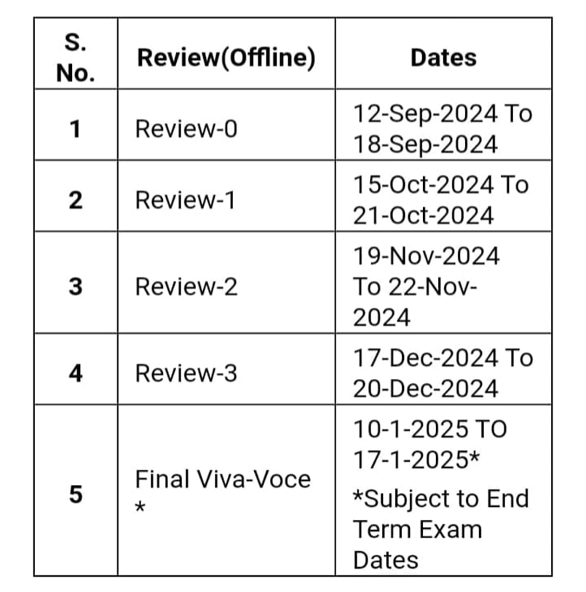

**8.CONCLUSION**

The tourism app project addresses a critical gap in the modern travel industry by offering a comprehensive, one-stop solution for travelers. By integrating essential travel services such as hotel bookings, cab reservations, event ticketing, and local activities into a single platform, the app simplifies the often fragmented and time-consuming process of travel planning. It focuses on providing a seamless user experience, ensuring convenience, personalization, and efficiency.

Through careful planning, robust system architecture, and the implementation of key features, the app is designed to cater to the diverse needs of travelers while offering them real-time updates, personalized recommendations, and streamlined booking options. Its cross-platform availability and user-friendly interface ensure that users can access and manage their travel plans easily from any device, at any time.

The app not only benefits users by saving time and enhancing their travel experience, but it also provides a scalable platform for future growth and integration of additional services. The potential for monetization and partnerships with service providers further solidifies the app's value in the market.

In conclusion, the project has the potential to transform the way people organize and experience their travel plans, offering a holistic solution that enhances convenience, reduces complexity, and improves overall satisfaction for travelers. By addressing existing inefficiencies in the travel service market, the app will emerge as a valuable tool for modern-day travelers seeking a more cohesive and efficient travel experience.

**9.REFERENCES**

|  |  |
| --- | --- |
| [1] | V. Garipelly, P. T. Adusumalli and a. P. Singh., "Travel recommendation system using content and collaborative," *a hybrid approach,* pp. 1-4, 2021. |
| [2] | K. C. a. A. Thakkar, "A comprehensive survey on travel recommender systems.," *Archives of Computational Methods in Engineering,* vol. 27, pp. 1545-1571, 2020. |
| [3] | P. Nitu and J. C. a. P. Madiraju, "Improvising personalized travel recommendation system with recency effects.," *Big Data Mining Analytics,* vol. 4, no. 3, pp. 139-154, 2021. |
| [4] | B.-L. Garcia, J.-Y. Potvin and a. J.-M. Rousseau., "A parallel implementation of the Tabu search heuristic for vehicle routing problems with time window constraints," *Comput. Oper. Res,* vol. 21, no. 9, p. 1025–1033, Nov 1994. |
| [5] | Q. Guo, " Liwei Scenic route planning algorithm based on grey entropy decision making model," *Comput. Eng. Des,* vol. 38, no. 7, p. 1988–1991, 2017. |
| [6] | J. Whittaker, Graphical Models in Applied Multivariate, 1990. |
| [7] | K. C. Tan, E. F. Khor and a. T. H. Lee, Multiobjective Evolutionary Algorithms and Applications, Londan, 2005. |
| [8] | Chai, Z. Y., S. S. Fang and a. Y. L. Li, "An improved decomposition based multiobjective evolutionary algorithm for IoT service," *IEEE Internet Things,J,* vol. 8, no. 2, p. 1109–1122, Jan 2021. |
| [9] | Jiang, E. D., Wang, L., Peng and a. Z. P., "Solving energy-efficient distributed job shop scheduling via multi-objective evolutionary algorithm with decomposition," *Swarm Evol. Comput,* vol. 58, p. 100745, Nov 2020. |
| [10] | Galindres-Guancha, L. F., E. Toro-Ocampo, Gallego-Rendón and a. R., "A biobjective capacitated vehicle routing problem using metaheuristic ILS and decomposition," *Int. J. Ind. Eng. Comput,* vol. 12, no. 3, p. 293–304, Apr 2021. |